Department of Biotechnology

Name of the Student | College Roll No. | Class | Marks in the University | Members of any society/organization | Measures were taken/ opportunities to enhance the skill and confidence of the students | Achievement/ outcome | Proof of the achievement/ outcome
SEHAJDEEP SAINI | 23108 | BSC. BIOTECHNOLOGY 1ST sem | 334/380 | JOINT SECRETARY (IPR CELL)  DISCIPLINE VOLUNTEER  MEMBER TASK FORCE  MEMBER IN PLACEMENT CELL  CLASS REPRESENTATIVE | Encouraged to participate in various competition E-COURSE AND  E- CERTIFICATE | CERTIFICATE:  Antimicrobial Stewardship: Improving Clinical Outcomes by Optimization of Antibiotic Practices  CERTIFICATE:  Learning how to use the COVID-19 Vaccine Introduction and deployment Costing (CVIC) tool | 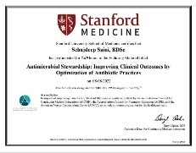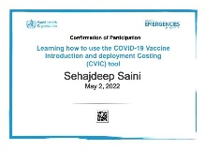
PALAK SHARMA | 23111 | BSC. BIOTECHNOLOGY 1STsem | 326/380 | DISCIPLINE VOLUNTEER  MEMBER PLACEMENT CELL | Encouraged to participate in various competition  E- CERTIFICATE | First prize in rangoli competition held at HMV jalandhar. | 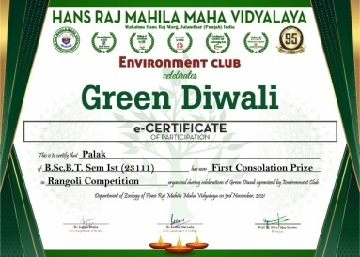
Bhavya Sharma | 23021 | BSc- BT (sem-3) | 334/380 | Member Career counseling cell , discipline volunteer. | E- seminars | Participation in sustainable use of biodiversity: entrepreneurship opportunities | 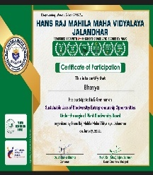
Srishti Sharma | 23019 | BSc-BT (sem-3) | 338/380 | Member placement cell | Online Certificate courses | NPTEL online courses, young scientists program | 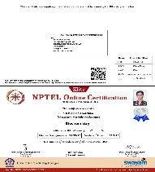
Isha Thakur | 23012 | BSc-BT (sem-3) | 292/380 | Secretary unat Bharat abhiyan cell,joint secretary discipline,joint secretary MOOCs cell, joint secretary H.M.V task force  Class representative | Power point presentation | Wildlife use in today’s science. | 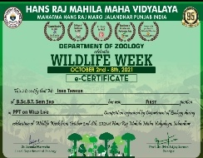
LUBNA NASIR | 10741922924 | BSc- BT (sem-5) | 396/420 | Member Career counseling cell , discipline volunteer. | E- seminars | Participated In Webinar On "How to Read Scientific  Literature?" And Successfully Completed the Online  Evaluation including the English Proficiency Test. Held at HMV jalandhar
TARANPREET KAUR | 10741922903 | BSc-BT (sem-5) | 394/420 | Class representative | Online Certificate courses | Participated In Webinar On "How to Read Scientific  Literature?" And Successfully Completed the Online  Evaluation including the English Proficiency Test. Held atHMV jalandhar
GAURI JINDAL | 10741922901 | BSc-BT (sem-5) | 392/420 | Head girl HMV Jalndhar | Poster making competition | Came 3rd in poster making competiton held atHMV jalandhar | 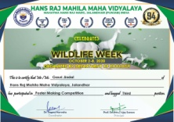

Slow Learners
Name of the Student | College Roll No. | Class | Marks in the University | Remedial measures taken | Outcome/ Achievement | Proof  (if any)
KOMAL VERMA | 23115 | BSc. BIOTECHNOLOGY 1St sem | Reappear in sem 1 | Written notes and books are provided | All clear
MANPREET KAUR | 23110 | BSc. BIOTECHNOLOGY 1ST sem | 225/380 | Written notes and books are provided | Increase in marks in next sem
Varsha | BSc-BT sem-3 | 23014 | Reappear in sem 1 | Written notes are provided | All clear in sem 3  289/360
Garima | BSc-BT (sem-3) | 23110 | 276/400 in sem 1 | Written notes are provided | 302/360 in sem 3
Rajveen kaur | BSc-BT sem-5 | 10741922904 | 248/420 BSc-BT sem-3 | Written notes are provided | 404/420 BSc-BT sem-4
Gouri | BSc-BT (sem-5) | 10741922904 | 285/420 BSc-BT sem-3 | Written notes are provided | 351/420 BSc-BT sem-5

